**Install the GSS for Sitecore module and add a reference to the GSS.dll in Visual Studio.**

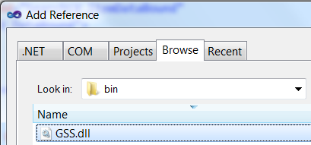

**After installing the module, update the Website node with your site settings or add additional GSS Site nodes for each website in your solution.**

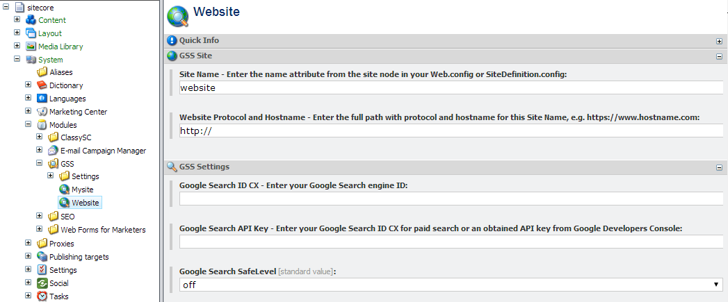

**Make a copy of your Search results Sublayout code in your Visual Studio project.**

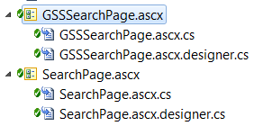

**Duplicate your search page Sublayout. You can keep your existing presentation layer and easily adapt it to work with GSS for Sitecore.**

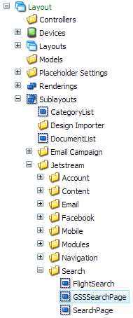

**Update the Codebehind and Inherits attributes on Line 1 of the new GSSSearchPage.ascx file.**

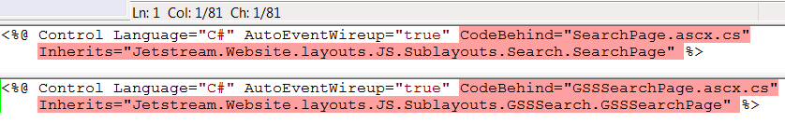

**Update the TypeName attribute of the ObjectDataSource to point to the GSSSearch namespace:  
Jetstream.Website.layouts.JS.Sublayouts.GSSSearch.WebsiteSearchDataAdapter**



**Update the namespace on Line 1 to be GSSSearch namespace.**

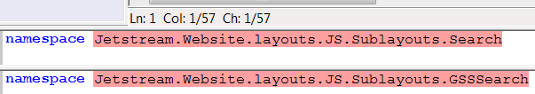

**Rename the class to be GSSSearchPage.**

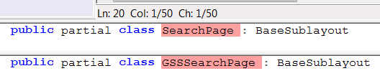

**Update the ItemDataBound event to bind on GSS object items.**

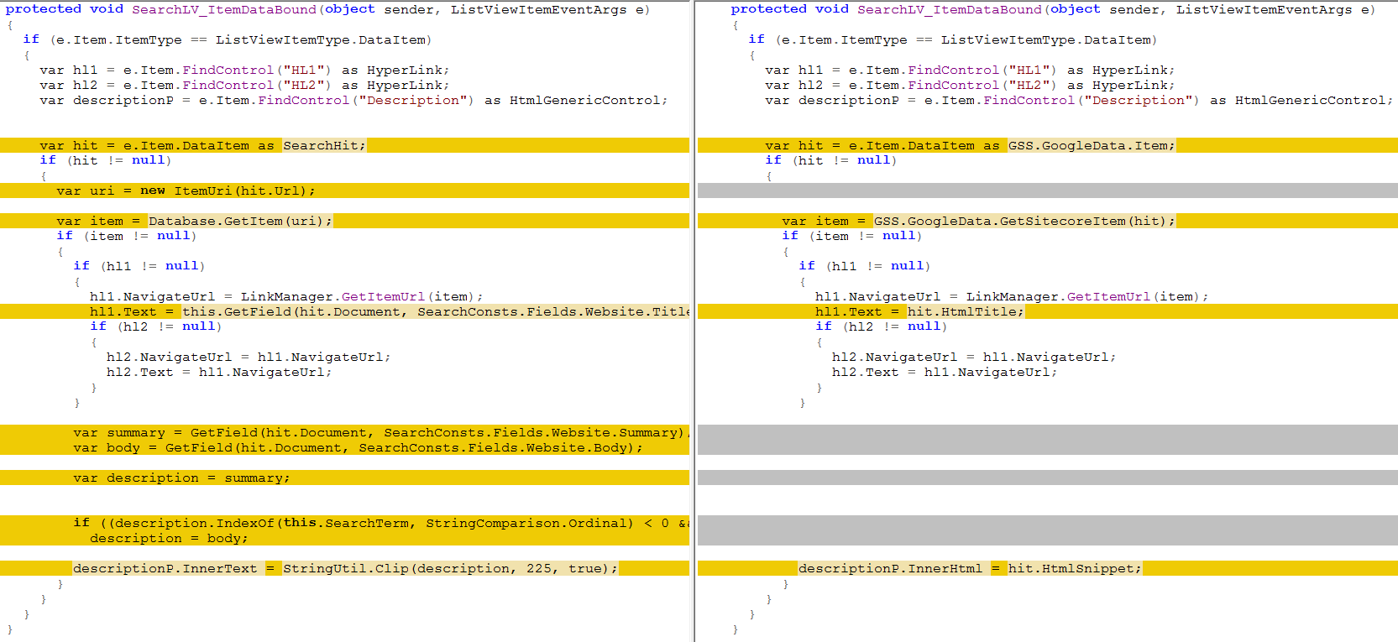

**Change the cast of e.Item.DataItem.**

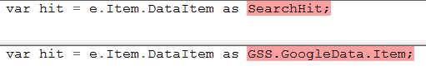

**Change the method for getting the Sitecore Item.**

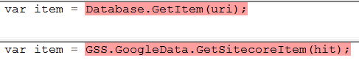

**Change the method for getting the Title to output.**

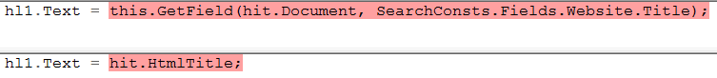

**Change the method for getting the Description HTML to output.**

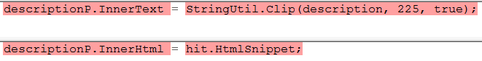

**Update the DataAdapter class.**

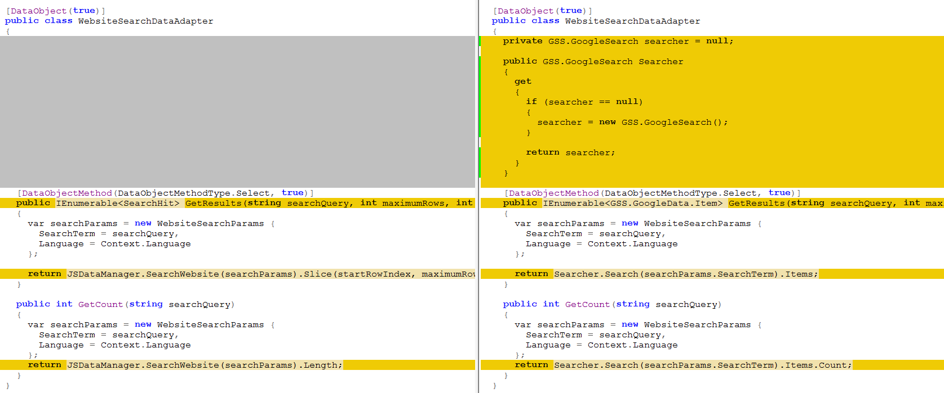

**Add an instance to the GSS searcher.**

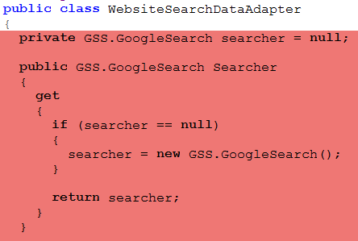

**Replace the IEnumerable class.**



**Replace the search method in the GetResults function.**



**Replace the search method in the GetCount function.**

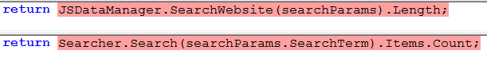

**Jetstream Search Page Layout Details using Lucene**

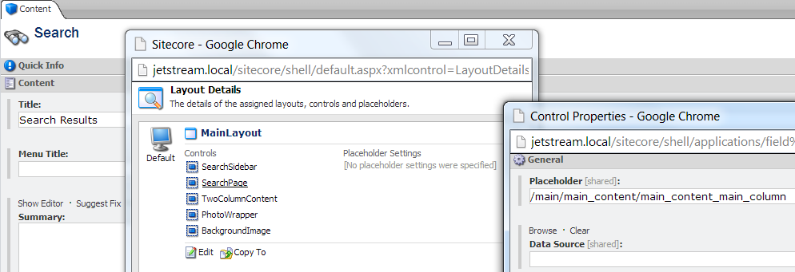



**Jetstream Search Page Layout Details using GSS**



